OUR LADY OF ENGLAND

PARISH PRIEST
Fr Charles Howell
2 St. John's, Fern Road, Storrington. RH20 4LW
Tel: 01903 740338
Email: storrington@dabnet.org
Website: www.ourladyofengland.com

PARISH SAFEGUARDING OFFICER:
Mrs Theresa Byrne Tel. 01903 744790

The Arundel & Brighton Diocesan Trust is a Registered Charity
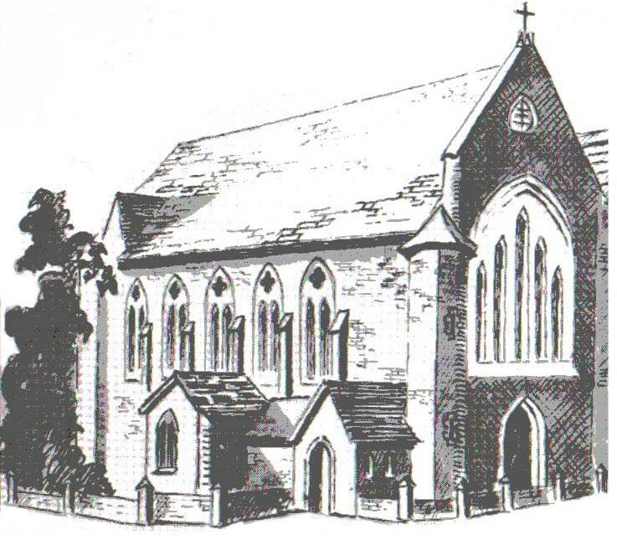

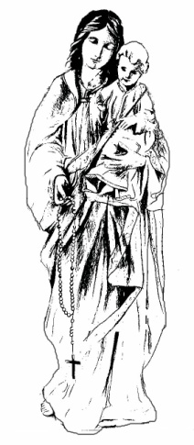

Solemnity: Christ the King, Year B – 25th November, 2018

MONDAY 26, Week 34 in Ordinary Time
9.00am Mass, November Holy Souls [esp. Sarah Matthews RIP]
(Revelation 14:1-3, 4B-5; Luke 21:1-4)

TUESDAY 27, Week 34 in Ordinary Time
9.00am Mass, November Holy Souls [esp. Mrs. Daphne Landells RIP]
(Revelation 14:14-19; Luke 21:5-11)

WEDNESDAY 28, Week 34 in Ordinary Time
No Mass
(Revelation 15:1-4; Luke 21:12-19)
8.00pm MUSIC PRACTICE at The Old Sanctuary, Fern Road

THURSDAY 29, Week 34 in Ordinary Time
No Mass
(Revelation 18:1-2, 21-23; 19:1-3, 9A; Luke 21:20-28)

FRIDAY 30, Feast: St Andrew, Apostle
9.00am Mass, November Holy Souls [esp. Mrs Ruth Davidson RIP
(Romans 10:9-18; Matthew 4:18-22)

SATURDAY 1, Our Lady on Saturday
9.00am Mass, Brian Shelock
followed by Exposition until 10.15, with Confessions available
(Revelation 22:1-7; Luke 21:34-36)
6.00pm Vigil Mass

NEXT SUNDAY 2, 1st Sunday of Advent, Year C
(Jeremiah 33:14-16; 1 Thessalonians 3:12—4:2; Luke 21:25-28, 34-36)

SUNDAY MASS TIMES
6pm Sat November Holy Souls 8.00am November Holy Souls
10.00am November Holy Souls

All are welcome to COFFEE IN THE HALL after 10am Mass every Sunday.

SACRAMENT OF RECONCILIATION
Saturday after the 9.00am Mass

THANK YOU FOR YOUR OFFERINGS
1st Collection: £599:59
2nd Collection: Arundel Cathedral Maintenance Fund £155:48

PRAYER OF THE CHURCH
Psalter Week: 2

TODAY Solemnity: Christ the King, Year B
No 2nd Collection

NEXT WEEK: 1st Sunday of Advent, Year C
No 2nd Collection

6pm Sat People of the Parish
8.00am William Walsh RIP
10.00am Sarah Matthews RIP

St Philip Howard Catholic School
Elm Grove South, Barnham
Tel: 01243 552055 www.sphcs.co.uk
St Philip’s Catholic Primary School
London Road, Arundel
Tel: 01903 882115 www.stphilipsarundel.org.uk
OUR LOCAL CATHOLIC SCHOOLS ARE:

NOVEMBER BOOK OF REMEMBRANCE ‘Holy Souls’ Masses will be offered throughout November and beyond. Plain brown offering envelopes are at the back of church for names to be included in the Book of Remembrance. Please write clearly, mark the envelope 'Remembrance', and place it in the offertory basket.

ADVENT DISCUSSION GROUPS: It is proposed to have two Advent groups: one on Tuesday evenings at 7.30pm and a second on Thursday afternoons at 2.30pm. Meetings begin this week on 27th and 29th November respectively, be held in the parish room and will last for an hour to an hour and a half. The subject matter will be a discussion of the readings for the forthcoming Advent Sunday. There are sign up lists on the main notice board in the porch.

ADVANCE NOTICE: Advent Reconciliation Service on Sunday 16th December at 4pm.
Christmas Masses: Night 9pm, Dawn 8am, Day 10am. New Year's Day (Mary, Mother of God) Mass at 12noon

REMINDER: Exposition of the Blessed Sacrament with Confessions, Saturdays 9.30 - 10.15, after 9am Mass. Especially recommended for Advent, and indeed throughout the year.

BISHOP RICHARD'S PASTORAL PLAN "The Word who is Life". Video and text available on the diocesan website. Full text with appendices, and summaries, will be made available once the series of deanery meetings have been completed in December.

READERS AND EUCHARISTIC MINISTERS NEW ROTA is now available in the porch

“CHRISTMAS FRIPPERIES” Monday 17th December Priory Hall 7:30pm Parish Social. An evening of light hearted songs, carols and candle lit festive fun to get you in the mood for Christmas. Presented by entertainers Michael and Stephanie. For the benefit of CAFOD. Tickets £10 include mulled wine, mulled apple juice, mince pies and seasonal treats. Tickets on sale after each Mass from 8th December also from Susan Crook 01798 815773 and Trevor Stauss 01903 366152.

PARISH WEBSITE: Newsletter upload temporarily suspended, please use the paper copies for now. New website under construction.

COFFEE ROTA 2019: Work commitments at weekends mean I need to hand over the coffee rota starting in January. If you could take it on please email me on olivia.hodgkinson@btinternet.com.
THINKING OF BECOMING A TEACHER? Teach South Central led by Bosco Teaching School Alliance Primary & Secondary teacher training recruitment event Wednesday 5th December 6.30pm – 7.30pm @ St Philip Howard Catholic School, Barnham PO22 0EN. For further details or to register for this event please email: TSAinfo@boscocet.org.uk

SVP are collecting inkjet cartridges and mobile phones for recycling. Place in the blue bag attached to the SVP noticeboard in the church porch.
SVP CONFERENCE & CAFOD SUPPORT GROUP would ask you to consider supporting them when shopping online by 1. Just visit easygiving.org.uk 2. Search for 'St Vincent de Paul Society' and/or 'Cafod' and follow the simple steps to sign up 3. Start shopping using links to over 2000 retailers. Each time you shop you will earn a donation to the charities and no cost to you. Thank you.

TWO OPPORTUNITIES FOR CHRISTMAS LUNCH The next Sunday Lunch Club meal will be Christmas turkey with all the trimmings on Sunday 9th December. Tickets at £4 are available from the Louisa Austen shop in Storrington, or Eileen Merchant on 01798 813911. Contact Eileen if you need transport.
Christmas Day lunch will also be at the Old School Hall. Admission £10 by ticket only from David and Jaqui Richardson on 01903 744178

ST PHILIP HOWARD CATHOLIC SCHOOL invites Senior Citizens to “Carols by Candlelight” Wednesday 12th December 2.30pm –3.45pm.
Please contact Jacqui Inglis by Wed 5th Dec to reserve seats (tel no 01243 558205).

CHEMIN NEUF Advent Quiet Day at Storrington priory Wednesday 5th December. Speaker: Fr. Stephen Ortiger OSB (one time Abbot of Worth Abbey) 10am - 3.30pm. Light lunch provided.
To book or more details contact Felicity on: ccn.storrington.desk@gmail.com

ENCOUNTER EVENING (FOR 16-35’s) Friday 7th December at 7.30pm, at Our Lady of Sorrows Parish, Bognor Regis. An engaging talk, live music & prayer, and social time. Entry is free, and there’s no need to book. Search for ‘ENCOUNTER Bognor Regis’ on Facebook for more information.

CHRISTMAS SHOE BOXES Many thanks for the excellent support for this charity. We gathered 52 boxes this year. These gifts will bring comfort to those living in great poverty in eastern Europe.

