Votive Mass of the Forty Martyrs
of England and Wales

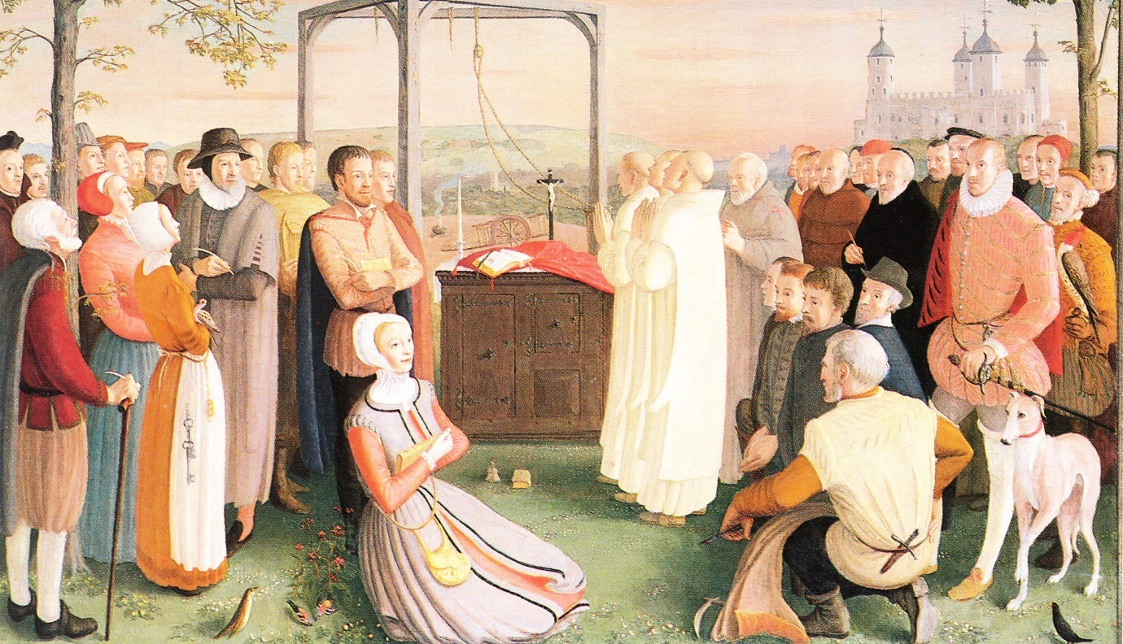

On the Fiftieth Anniversary of their Canonisation

1970 - 25th October - 2020

THE FORTY MARTYRS

The feast of the Forty Martyrs of England and Wales honours the hundreds of British men and women who suffered persecution and died for their Catholic faith during the sixteenth and seventeenth centuries in the wake of the dispute between the Pope and King Henry VIII. Countless loyal Catholics were tortured and killed between 1535 and 1679.

On 4th May 1535, the first of these many martyrs of the English Reformation were hanged, drawn and quartered on the gallows at Tyburn. Although some have been canonised or beatified, the true number of those who died on the scaffold, perished in prison, or were tortured or persecuted for their faith – the ancient faith of their country – is not known. Thousands of others were driven into exile or deliberately reduced to penury under merciless penal laws.
The martyrs celebrated today came from every walk of life: rich and poor; married and single; men and women; priests, religious and lay people. They are remembered for the example they gave of constancy in their faith, and courage in the face of persecution which lasted almost a hundred and fifty years and left a permanent mark on English culture.

When King Henry VIII, after his break with Rome, proclaimed himself “the only Supreme head on earth of the Church of England”, Catholics felt that he had appropriated a supremacy in spiritual matters that belonged only to the Pope. While they wished to remain loyal subjects of the Crown, as the legitimately constituted authority, for reasons of conscience they refused to recognise the ‘spiritual supremacy’ of the King. When the Act of Supremacy was passed in 1534, many faced a serious dilemma, and even death, rather than act against their conscience and deny their Catholic faith. (From an ecumenical point of view, it is important to note that these deaths were not the result of internal struggles between Catholics and Anglicans; rather, that those who died were not willing to submit to what they saw was an illegitimate claim of the State. The schism created by Henry set in motion more than a century of religious turmoil during which Protestants were sometimes burned for heresy, with some 300 dying during the five-year reign of Queen Mary I as she struggled to re-establish the Catholic faith in England.)

There were four distinct waves of persecution. The first followed the passing of the Act of Supremacy in 1534 when Henry VIII broke with Rome and suppressed the monasteries. The second came after 1570 when Pope Pius V, believing that Queen Elizabeth I was illegitimate and had no right to the throne of England, issued a papal bull excommunicating her and absolving all her subjects from allegiance to her and her laws. Persecution intensified markedly in the latter half of Elizabeth’s reign, following the arrival of the Jesuits on the English Mission, coupled with the threat of invasion by Spain. In 1581 an Act was passed that made it treason to withdraw English subjects from allegiance to the Queen or her Church, and in 1585 the entrance of Jesuits into the country was prohibited by law. The third wave followed the failed Gunpowder Plot in 1605. The final wave came in 1678, following the so-called ‘Popish Plot’, a totally fictitious but widely believed plot, fabricated by Titus Oates, in which it was alleged that Jesuits were planning to overthrow King Charles II in order to bring his Catholic brother (later King James II) to the throne. Even this rumour was enough to stir a new and unprecedented era of persecution for Catholics.

The cause of about three hundred martyrs was introduced in Rome shortly after the restoration of the Catholic hierarchy of England and Wales in 1850, and the long campaign began under Cardinals Wiseman and Manning. By 1935, nearly two hundred Reformation martyrs had been beatified (by Leo XIII and Pius XI), but only two of these had been canonised: in 1936, Cardinal John Fisher, Bishop of Rochester, and Henry VIII’s chancellor, Sir Thomas More, became the first Englishmen to be made saints since John of Bridlington in 1401. After the Second World War, the cause was revived in 1960 and, in 1970, the Vatican selected forty martyrs, men and women, lay and religious to represent the full group. On 25th October 1970, at St Peter's in Rome, Pope Paul VI canonised these forty English and Welsh martyrs as saints. Auberon Waugh described it as “the biggest moment for English Catholicism since Catholic emancipation in 1829”.

In England, these martyrs were formerly commemorated by a feast day on 25th October, but they are now celebrated together with all the canonised or beatified martyrs of the English Reformation on 4th May. Each of the forty martyrs has their own day of memorial, but they are remembered as a group on this date, marking the first deaths at Tyburn in 1535 of those observed from the Tower of London by Thomas More “cheerfully going to their deaths as bridegrooms to their marriage.”
In Wales, 25th October is kept as the feast of the Six Welsh Martyrs (from the group of forty) and their companions (the thirty-four English Martyrs). Wales continues to keep 4th May as a separate feast for the beatified martyrs of England and Wales.

READINGS AND PRAYERS FOR THE VOTIVE MASS

The readings and Preface given here for the fiftieth anniversary celebration are those used at the Mass of Canonisation in Rome on 25th October 1970.
The Prayers of the Mass are those for the Feast of the English Martyrs (4th May) in the Roman Missal.

The full texts of the readings are provided for ease of use as they do not appear exactly in this form in the Lectionary.
______________________________________________________________________________________

Liturgical Colour: Red

Prayers of the Mass: 4th May – The English Martyrs (RM pp. 902-903)

Preface: Preface I of Saints – The glory of the Saints (RM p. 632)

Readings:
1st Reading: Isaiah 53: 3-11
Psalm: Psalm 15 – Preserve me God, I take refuge in you.
2nd Reading: Hebrews 11: 33 – 12: 2
Gospel Acclamation: Cf. Te Deum
Gospel: John 17: 11-21

______________________________________________________________________________________

Music sung during the Canonisation Mass included:
Missa de Angelis
Credo III
“Praise to the Holiest” (Presentation of Gifts),
A setting of “The Lord’s my Shepherd” (Communion)
“For all the Saints” (Final hymn)

“Holy God, we praise thy name” would be another suitable hymn, if music is possible, remembering that congregational singing is not permitted at this time.

Copyright Acknowledgements

Excerpts from the English translation of The Roman Missal © 2010,
International Commission on English in the Liturgy Corporation. All rights reserved.

Scripture extracts from The Jerusalem Bible © 1966 by Darton Longman & Todd Ltd
and Doubleday and Company Ltd.

Psalm text © 1963 The Grail (England), published by HarperCollins.

Entrance Antiphon
Cf. Rev. 7: 13-14
These who are clothed in white robes
are they who have survived the time of great distress
and have washed their robes in the blood of the Lamb.

Collect

Almighty God,
who in our country raised up martyrs from every walk of life
to vindicate the authority of your Church in teaching and worship,
grant through their intercession, we pray,
that all our people may be gathered once again to celebrate the same sacraments
under the one Shepherd, Jesus Christ your Son.
Who lives and reigns with you in the unity of the Holy Spirit,
one God, for ever and ever.

Prayer over the Offerings

Look with such serenity and kindness, we pray, O Lord,
upon these present offerings,
that they may be filled with the blessing of the Holy Spirit
and may stir in our hearts that powerful love
through which the holy Martyrs overcame every bodily torment.
Through Jesus Christ our Lord.

Communion Antiphon
Cf. Rev 2: 7
To the victor I will give the right to eat from the tree of life,
which is in the paradise of my God.

Prayer after Communion

Restored by the sustenance of the one Bread, O Lord,
on the commemoration of the blessed Martyrs
we humbly pray,
that you may confirm us ever in your charity
and make us walk in newness of life.
Through Christ our Lord.

First Reading
Isaiah 53: 3-11
He was pierced through for our faults.

A reading from the prophet Isaiah.

He was despised and rejected by men,
a man of sorrows and familiar with suffering,
a man to make people screen their faces;
he was despised and we took no account of him.

And yet ours were the sufferings he bore,
ours the sorrows he carried.
But we, we thought of him as someone punished,
struck by God, and brought low.
Yet he was pierced through for our faults,
crushed for our sins.
On him lies a punishment that brings us peace,
and through his wounds we are healed.

We had all gone astray like sheep,
each taking his own way,
and the Lord burdened him with the sins of all of us.
Harshly dealt with, he bore it humbly,
he never opened his mouth,
like a lamb that is led to the slaughter-house,
like a sheep that is dumb before its shearers
never opening its mouth.

By force and by law he was taken;
would anyone plead his cause?
Yes, he was torn away from the land of the living;
for our faults struck down in death.
They gave him a grave with the wicked,
a tomb with the rich,
though he had done no wrong
and there had been no perjury in his mouth.
The Lord has been pleased to crush him with suffering.
If he offers his life in atonement,
he shall see his heirs, he shall have a long life
and through him what the Lord wishes will be done.

His soul’s anguish over
he shall see the light and be content.
By his sufferings shall my servant justify many,
taking their faults on himself.

The word of the Lord.

Responsorial Psalm
Psalm 15: 1-2. 5. 7-11

R/ Preserve me, God, I take refuge in you.

- Preserve me, God, I take refuge in you.
I say to the Lord: ‘You are my God.’
O Lord, it is you who are my portion and cup;
it is you yourself who are my prize.

- I will bless the Lord who gives me counsel,
who even at night directs my heart.
I keep the Lord ever in my sight:
since he is at my right hand, I shall stand firm.

- You will show me the path of life,
the fullness of joy in your presence,
at your right hand happiness for ever.

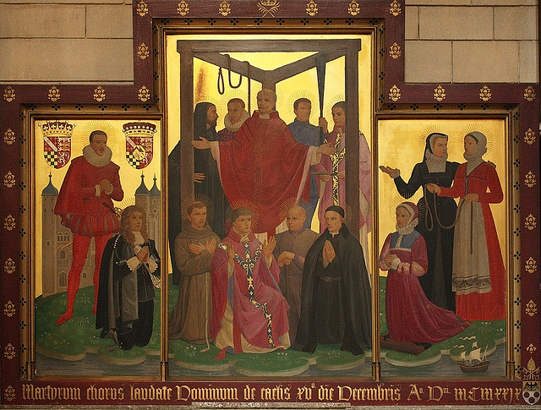

Icon of the English Martyrs at Tyburn Convent (Photograph: Lawrence OP)

Second Reading
Hebrews 11: 33 - 12: 2
Through faith they conquered kingdoms.
God will make provision for us to have something better.

A reading from the Letter to the Hebrews.

Gideon, Barak, Samson, Jephthah, David, Samuel and the prophets –
these were men who, through faith, conquered kingdoms,
did what is right and earned the promises.
They could keep a lion’s mouth shut, put out blazing fires and emerge unscathed from battle.
They were weak people who were given strength,
to be brave in war and drive back foreign invaders.
Some came back to their wives from the dead, by resurrection;
and others submitted to torture, refusing release so that they would rise again to a better life.
Some had to bear being pilloried and flogged, or even chained up in prison.
They were stoned, or sawn in half, or beheaded;
they were homeless, and dressed in the skins of sheep and goats;
they were penniless and were given nothing but ill-treatment.
They were too good for the world
and they went out to live in deserts and mountains and in caves and ravines.

These are all heroes of faith,
but they did not receive what was promised,
since God had made provision for us to have something better,
and they were not to reach perfection except with us.

With so many witnesses in a great cloud on every side of us,
we too, then, should throw off everything that hinders us,
especially the sin that clings so easily,
and keep running in the race we have started.
Let us not lose sight of Jesus,
who leads us in our faith and brings it to perfection:
for the sake of the joy which was still in the future,
he endured the cross, disregarding the shamefulness of it,
and from now on has taken his place at the right of God’s throne.

The word of the Lord.

Gospel Acclamation
cf. Te Deum
Alleluia, alleluia!
We praise you, O God, we acknowledge you to be the Lord;
the noble army of martyrs praise you, O Lord.
Alleluia!

Gospel
John 17: 11-21
The world hated them.

Jesus raised his eyes to heaven and said:

‘Holy Father,
keep those you have given me true to your name,
so that they may be one like us.
While I was with them,
I kept those you had given me true to your name.
I have watched over them and not one is lost
except the one who chose to be lost,
and this was to fulfil the scriptures.
But now I am coming to you
and while still in the world I say these things
to share my joy with them to the full.
I passed your word on to them,
and the world hated them,
because they belong to the world no more than I belong to the world.
I am not asking you to remove them from the world,
but to protect them from the evil one.
They do not belong to the world any more than I belong to the world.
Consecrate them in the truth;
your word is truth.
As you sent me into the world,
I have sent them into the world,
and for their sake I consecrate myself
so that they too may be consecrated in truth.

I pray not only for these,
but for those also
who through their words will believe in me.
May they all be one.
Father, may they be one in us,
as you are in me and I am in you,
so that the world may believe it was you who sent me.’

The Gospel of the Lord.
BRIEF LIVES OF THE FORTY MARTYRS

(as presented in the order of service booklet for the Canonisation Mass in 1970)

1535

St. John Houghton, priest, Carthusian monk, Prior of London Charterhouse. Born in Essex, he studied at the University of Cambridge. He was condemned to death for refusing to accept King Henry VIII as supreme head of the Church in England, and was hanged, drawn and quartered. "I am bound in conscience," he said, "and am ready and willing to suffer every kind of torture rather than deny a doctrine of the Church,"
Tyburn, 4th May

St. Robert Lawrence, priest, Carthusian monk, Prior of Beauvale, Notts. His birthplace is unknown and little is certain about his early life. He was condemned to death, and hanged, drawn and quartered with St. John Houghton and for the same reason. Questioned about the King as head of the Church, he replied that he "could neither consent nor believe that the King's highness was supreme head of the Church in England."
Tyburn, 4th May

St. Augustine Webster, priest, Carthusian monk, Prior of Axholme, Lincs. His birthplace is unknown, and we have no details of his early life except that he studied at the University of Cambridge. He was condemned to death with Saints John Houghton and Robert Lawrence and for the same reason, and was hanged, drawn and quartered with them.
"I cannot take the King to be supreme head of the Church," he said, "but him that is by the Doctors of the Church taken as head of the Church."
Tyburn, 4th May

St. Richard Reynolds, priest, Bridgettine monk of Syon Abbey, Middlesex. Born in Devon, he studied at the University of Cambridge. He was condemned to death, and hanged, drawn and quartered with the three preceding Carthusians, and for the same reason. The last to be executed, he encouraged the others, promising them "a heavenly banquet and supper for their sharp breakfast taken patiently for their Master's sake".
Tyburn, 4th May

1539

St. John Stone, priest, Augustinian friar, of the Canterbury community. Nothing is known for certain of his birthplace or life previous to his arrest in 1538. Condemned to death for refusing to accept King Henry VIII as supreme head of the Church in England, he was hanged, drawn and quartered. An early picture (c. 1600) bears an inscription describing him as "a most zealous defender of the faith, in the defence of which he died".
Canterbury, December (exact day not known)

1577

St. Cuthbert Mayne, seminary priest. Born near Barnstaple, Devon, he studied at Barnstaple Grammar School, St. John's College in Oxford, and Douai, where he was ordained priest in 1575. Returning to England in 1576, he worked in Cornwall until his arrest the following year. Charged with promulgating a papal bull in England, he was condemned to death, and hanged, drawn and quartered. He is the protomartyr of the English seminaries abroad. When a messenger told him he was to be executed in three days, he answered: "If I had anything to give, I would rather bestow it upon you than any other, for you have done more for me than ever any man did."
Launceston, 30th November

1585

St. Edmund Campion, Jesuit priest. Born in London, he studied there, at St. John's College in Oxford, and at Douai. After entering the Society of Jesus in Rome in 1573, he spent some time in Prague, where he was ordained priest in 1578. Returning to England in 1580, he was arrested the following year, condemned to death for alleged plotting against Queen Elizabeth I, and hanged, drawn and quartered. On the scaffold, told to ask the Queen's forgiveness and to pray for her, he replied: "Yea, I pray for Elizabeth, your Queen and mine, unto whom I wish a long quiet reign with all prosperity."
Tyburn, 1st December

St. Ralph Sherwin, seminary priest. Born at Rodsley, near Longford, Derbyshire, he studied at Exeter College, Oxford, at Douai, where he was ordained priest in 1577, and at Rome. Arrested shortly after his return to England in 1580, he was condemned to death with St. Edmund Campion and on the same charge, and hanged, drawn and quartered with him. He is the protomartyr of the Venerable English College, Rome. On the scaffold he declared: "I forgive all who, either by general presumption or particular error, have procured my death."
Tyburn, 1st December

St. Alexander Briant, Jesuit priest. Born in Somerset, he studied at Hart Hall, Oxford, and at Douai, where he was ordained priest in 1578. Returning to England the following year, he worked in Somerset, but was arrested in London in 1581. He was condemned to death the day after Saints Edmund Campion and Ralph Sherwin, on the same charge, and was hanged, drawn and quartered with them. Describing his experience under torture, he wrote: "As well as I could I did muse and meditate upon the most bitter Passion of our Saviour, and how full of innumerable pains it was."
Tyburn, 1st December

1582

St. John Payne, seminary priest. Born in Peterborough, he studied at Douai, where he was ordained priest in 1576. Returning to England the same year, he worked chiefly at Ingatestone, Essex. Arrested in 1581, he was condemned to death for alleged plotting against Queen Elizabeth I, and hanged, drawn and quartered. To the Lieutenant of the Tower he wrote: "Touching her Majesty, I pray God long to preserve her Highness to his honour and her heart's desire.
Unto her I always have, and during life will wish no worse than to my own soul."
Chelmsford, 2nd April

St. Luke Kirby, seminary priest. Born at Bedale, N Yorks., he studied probably at the University of Cambridge, at Douai, where he was ordained priest in 1577, and at Rome. Arrested on landing in England in 1580, he was condemned to death with Saints Edmund Campion and Ralph Sherwin, on the same charge, and after a further six months in prison he was hanged, drawn and quartered. Asked on the scaffold whether he thought the Queen to be supreme governor of the Church in England, he answered: "I am ready to yield her as much authority as any other subject ought to yield his prince, or as he would yield to Queen Mary, and more with safety of conscience I cannot do."
Tyburn, 30th May

1584

St. Richard Gwyn, layman. Born at Llanidloes, Montgomeryshire, he studied at St. John's College, Cambridge, and then became a schoolmaster in Flintshire and Denbighshire. Arrested in 1578, he escaped, but he was arrested again in 1580 and spent the remaining four years of his life in prison. After being tried at eight separate Assizes, he was finally condemned to death for refusing to recognise Queen Elizabeth I as head of the Church in England, and was hanged, drawn and quartered. He is honoured as the protomartyr of Wales. Meeting a crowd of sympathisers as he left the gaol for his martyrdom, he said to them: "Weep not for me, for I do but pay the rent before rent-day."
Wrexham, 17th October

1586

St. Margaret Clitherow, laywoman, née Middleton. Born at York, she was the wife of a butcher of that city. Arrested in 1586, she was found guilty of harbouring priests, and was pressed to death because she refused to plead before the court. "If God's priests dare venture themselves into my house," she declared, "I will never refuse them."
York, 25th March

1588

St. Margaret Ward, laywoman. She was born at Congleton, Cheshire, but nothing much is known of her early life. Condemned to death for helping a priest to escape from the Bridewell prison in London, by smuggling in a rope to him, she was hanged. At her trial she said she was willing to lay down not one life only but many, if she had them, rather than betray her conscience or act against her duty to God and his holy religion.
Tyburn, 30th August

1591

St. Edmund Gennings, seminary priest. Born at Lichfield, Staffs., he studied at Rheims, where he was ordained priest in 1590. Returning to England the same year, he worked for about six months in the north of England. He was arrested in London and condemned to death for his priesthood, and was hanged, drawn and quartered. He was the first priest amongst the Forty Martyrs to suffer under the famous statute of 1585 against Jesuits and seminary priests. On the scaffold he said: "If to return into England priest, or to say Mass, be popish treason, I here confess that I am a traitor;
but I think not so, and therefore I acknowledge myself guilty of those things, not with repentance, but with an open protestation of inward joy. Saint Gregory, pray for me."
Gray's Inn Fields, 10th December

St. Swithun Wells, layman, of Bambridge, near Winchester, Hants. For many years he was a schoolmaster at Monkton Farleigh, Wilts. Arrested in London in 1591, he was condemned to death for harbouring St. Edmund Gennings, and hanged. On the way to execution he called out to a friend: "Farewell, dear friend! Farewell all hawking, hunting, and old pastimes! I am now going a better way."
Gray's Inn Fields, 10th December

St. Eustace White, seminary priest. Born at Louth, Lincs., he studied at Rome, where he was ordained priest in 1588. Returning to England the same year, he worked in the West Country. Arrested in 1591, he was condemned to death for his priesthood, and hanged, drawn and quartered. Under torture he prayed: "Lord, more pain if thou pleasest, and more patience." To Richard Topcliffe, the famous persecutor of Catholics, he said: "I am not angry with you for all this, but shall pray to God for your welfare and salvation."
Tyburn, 10th December

St. Polydore Plasden, seminary priest. Born in London, he studied at Rheims and Rome, where he was ordained priest in 1586. Returning to England, he worked in London until his arrest in 1591. He was condemned to death for his priesthood, and hanged, drawn, and quartered. To the Lord Chief Justice he said: "These twelve simple men find us guilty of treason for exercising our priestly function. But you, learned in the law and history, know quite well that the priestly function was in all ages an honourable calling."
Tyburn, 10th December

1594

St. John Boste, seminary priest. Born at Dufton, Westmorland, he studied at Queen's College, Oxford, and at Rheims, where he was ordained priest in 1581. Returning to England soon afterwards, he worked in the north of England for twelve years, until his arrest in 1593. He was condemned to death for his priesthood, and hanged, drawn and quartered. On the scaffold, when told to ask the Queen's pardon, he replied; "I have never offended her. I take it upon my death that I never went about to hurt her. I wish to God that my blood may be in satisfaction for my sins."
Durham, 24th July

1595

St. Robert Southwell, Jesuit priest. Born at Horsham St. Faith, Norfolk, he studied at Douai for two years, then entered the Society of Jesus in Rome in 1578 and was ordained priest there in 1584. Returning to England in 1586, he worked in and around London for six years. Arrested in 1592, he was imprisoned and severely tortured. Finally he was condemned to death for his priesthood, and hanged, drawn and quartered. On the scaffold his last words were: "This is my death, my last farewell to this unfortunate life, and yet to me most happy and most fortunate. I pray it may be for the full satisfaction of my sins, for the good of my country, and for the comfort of many others."
Tyburn, 21st February

St. Henry Walpole, Jesuit priest. Born at Docking, Norfolk, he studied at Norwich Grammar School, Peterhouse in Cambridge, Gray's Inn in London, and at Rome. He entered the Society of Jesus in Rome in 1584 and was ordained priest there in 1588. Returning to England in 1593, he was captured almost immediately. Imprisoned for a time in the Tower of London, where he was severely tortured, he was finally tried at York, condemned to death for his priesthood, and hanged, drawn and quartered. At his trial he said: "I confess most willingly that I am a priest and a Jesuit, and that I came over to convert my country to the Catholic faith and to invite sinners to repentance."
York, 7th April

St. Philip Howard, Earl of Arundel, layman. Born at Arundel House, London, he studied at St. John's College, Cambridge, and as a young man was received with favour at the court of Queen Elizabeth I. Reconciled to the Catholic Church in 1584, he was arrested the following year as he was about to escape to the Continent. He spent the remaining ten years of his life in prison in the Tower of London, where he suffered great privations. Put on trial in 1589 for having been reconciled to the Catholic Church and for alleged plotting against the Queen, he was condemned to death, but the sentence was not carried out and he died in prison more than six years later. On the wall of his cell he carved the words: "The more suffering for Christ in this life, the more glory with Christ in the life to come."
Tower of London, 19th October

1598

St. John Jones, Franciscan priest. Born at Clynog Fawr, Caernarvonshire, he joined the Franciscan Order probably at Pontoise in France and was professed at Ara Coeli convent in Rome. Returning to England in 1592, he worked in London until his arrest in 1597. He was tried the following year, condemned to death for his priesthood, and hanged, drawn and quartered. In his last moments, on the scaffold, he declared: "I have never spoken a word or entertained a thought in my whole life against the Queen or my country, but have prayed daily for their welfare."
Southwark, 12th July

1600

St. John Rigby, layman. Born at Harrock Hall, near Wigan, Lancs., he was employed as a steward at Sawston Hall, Cambridge. He was arrested in London, condemned to death for being reconciled to the Catholic Church, and hanged, drawn and quartered. On being sentenced he said: "This is a fleabite in comparison of what it pleased my sweet Saviour to suffer for my salvation. I freely forgive your Lordship, and the poor jury, and all other persecutors whatsoever."
Southwark, 21st June

1601

St. Anne Line, laywoman, née Higham. Born at Dunmow, Essex. After her husband's death in 1594 she took charge of the house for priests established in London by Fr. John Gerard, S.J. She was condemned to death for harbouring priests, and hanged. When reproached on the scaffold for being a 'receiver of priests', she declared herself entirely unrepentant of this, and added: "Where I have received one, I would to God that I had been able to have received a thousand."
Tyburn, 27th February

1606

St. Nicholas Owen, Jesuit brother. Born in Oxford, he was the companion of Fr. Henry Garnet, S.J., for many years, and is famous for the hiding-holes for priests which he constructed in houses throughout England. Arrested in 1606, he was severely tortured in the Tower of London, but he refused to reveal anything regarding priests or Catholics, and finally died under torture. Of him Fr. John Gerard, S.J., wrote: "I verily believe no man can be said to have done more good of all those who laboured in the English vineyard."
Tower of London, 2nd March

1608

St. Thomas Garnet, Jesuit priest. Born in Southwark, London, he studied at Horsham Grammar School, St. Omer, and Valladolid, where he was ordained priest. He returned to England in 1599, and entered the Society of Jesus in England in 1604. Arrested in 1606, he was banished from England, but he returned again the following year and was soon back in prison. He was condemned to death for his priesthood and hanged, drawn and quartered. On the scaffold he said: "May God pardon Rouse, who betrayed me, Cross, who apprehended me, the Bishop of London, who thrust me into prison, Sir William Wade, the Prefect of the Tower, who eagerly solicited my death, and the Attorney General, who invented so many things against me. May all attain salvation, and with me reach heaven."
Tyburn, 23rd June

1610

St. John Roberts, Benedictine priest. Born at Trawsfynydd, Merionethshire, he studied at St. John's College, Oxford, and at Valladolid, where he entered the Benedictine Order and was ordained priest in 1602. He returned to England in 1603 and worked for nearly eight years, during which period he was arrested five times and banished from England on three separate occasions. Finally he was condemned to death for his priesthood, and hanged, drawn and quartered.
At Tyburn, noticing the fire prepared for the boiling of his quarters after death, he said pleasantly: "Here's a hot breakfast towards, despite the cold weather."
Tyburn, 10th December

1612

St. John Almond, seminary priest. Born at Allerton, Liverpool, he studied at the nearby grammar school at Much Woolton, then in Ireland, and finally in Rome, where he was ordained priest in 1601. He returned to England in 1602 and worked in England for the next ten years, spending some time in gaol about 1608. He was again arrested in 1612 and condemned to death for his priesthood. On the scaffold, just before his execution, he said: "Death is the gate of life unto us, whereby we enter into everlasting blessedness."
Tyburn, 5th December

1628

St. Edmund Arrowsmith, Jesuit priest. Born at Haydock, Lancs., he studied at Douai, where he was ordained priest in 1612. He worked in Lancashire from 1613 to 1628, spending a while in prison probably about 1622, and in 1624 he entered the Society of Jesus. He was tried at Lancaster in 1628 and condemned to death for his priesthood and for "persuading to popery", and hanged, drawn and quartered. "Bear witness," he said, "you who are come to see my end, that I die a constant Roman Catholic, and for Jesus Christ's sake let not my death be a hindrance to your welldoing and going forward in the Catholic religion, but rather may it encourage you thereto."
Lancaster, 28th August

1641

St. Ambrose Barlow, Benedictine priest. Born at Barlow Hall, Manchester, he studied at Douai and Valladolid. Entering the Benedictine Order at Douai in 1615, he was ordained priest in 1617 and then returned to England and worked for twenty-four years in south Lancashire. He was condemned to death for his priesthood and hanged, drawn and quartered. At his trial, when offered freedom if he would undertake not to "seduce" the people any more, he replied: "I am no seducer, but a reducer of the people to the true and ancient religion."
Lancaster, 10th September

1642

St. Alban Roe, Benedictine priest. Born in Suffolk, he studied at the University of Cambridge and at Douai. He entered the Benedictine Order at Dieulouard in France in 1612, was ordained priest, and then returned to England. He was imprisoned in England and banished in 1623, but was soon back again. After about two years he was again arrested and spent the remainder of his life, about seventeen years, in prison. His confinement was not very strict, however, for he was allowed to receive visitors and even to go out on parole during the day, and thus he was able to carry on his priestly ministry. Finally he was put on trial, condemned to death for his priesthood, and hanged, drawn and quartered. After blessing those who had assisted at the Masses of himself and another martyr on the morning of their execution, he said to them: "When you see our heads high up on London Bridge, take it that they are there simply to preach to you, to proclaim that very faith for which we are about to die."
Tyburn, 31st January

1645

St. Henry Morse, Jesuit priest. Born at Brome, Suffolk, be studied at Corpus Christi College in Cambridge, Barnard's Inn in London, and at Douai and Rome, where he was ordained priest in 1624. Returning to England, he was admitted to the Society of Jesus in 1625. Arrested in 1626 and banished from England about 1630, he was back again in 1633. He is remembered especially for his heroic work in London during the plague of 1635-36. He was arrested again in 1644, condemned to death for his priesthood, and hanged, drawn and quartered. On the scaffold he addressed the people and ended by saying; "I pray that my death may be some kind of atonement for the sins of this kingdom, and if I had as many lives as there are sands on the seashore, I should willingly lay them down for this land and to testify to the truth of the Catholic faith."
Tyburn, 1st February

1654

St. John Southworth, seminary priest. Born in Lancashire, he studied at Douai, where he was ordained priest in 1619, and then returned to England. He was arrested in Lancashire in 1627 and condemned to death for his priesthood, but was reprieved and in 1630 banished from England. He was soon back again, and in the years 1635-36 he worked with St. Henry Morse amongst the plague-stricken in London. He suffered three further periods of imprisonment before his final arrest in 1654, when he was again condemned to death for his priesthood. This time the sentence was carried out and he was hanged, drawn and quartered. At Tyburn, as he beheld the scaffold prepared for him, he said: "This gallows I look on as his cross, which I gladly take to follow my dear Saviour. My faith is my crime, the performance of my duty the occasion of my condemnation."
Tyburn, 28th June

1679

St. John Plessington, seminary priest. Born at Dimples Hall, near Garstang, Lancs., he studied at a Jesuit school at Scarisbrick Hall, near Ormskirk, at St. Omer, and at Valladolid. Ordained priest at Segovia in 1662, he returned to England the following year and worked at Holywell in Flintshire and Puddington in Cheshire. He was arrested at the time of the Titus Oates plot, condemned to death for his priesthood, and hanged, drawn and quartered. In his speech from the scaffold he said: "Dear countrymen, nothing was laid to my charge but priesthood, and you will find that priesthood is neither against the law of God, nor monarchy, nor civil government."
Chester, 19th July

St. Philip Evans, Jesuit priest. Born at Monmouth, he studied at St. Omer, where he entered the Society of Jesus in 1665. He was ordained priest at Liège in 1675 and returned home and began to work in south Wales the same year. Arrested in December 1678, he was condemned for his priesthood, and hanged, drawn and quartered. When told that his execution was to take place the following morning, he is said to have continued a game of tennis he was playing with St. John Lloyd (see below), and then sat down to a harp, lent him by the gaoler, to express his joy in song.
Cardiff, 22nd July

St. John Lloyd, seminary priest. Born in Brecknockshire, he studied at Ghent and Valladolid, where he was ordained priest in 1653. The following year he returned to Wales, where he laboured for the next twenty-four years. Arrested in November 1678, he was condemned to death for his priesthood, and hanged, drawn and quartered. On the scaffold before his death he said: "I die in the true Catholic and apostolic faith. I forgive all those that have offended me, and if I have offended anybody I am heartily sorry for it and ask their forgiveness. Lord, have mercy upon me, a sinner."
Cardiff, 22nd July

St. John Wall, Franciscan priest. Born in Lancashire, he studied at Douai and Rome, where he was ordained priest in 1645. He returned to England in 1648, then joined the Franciscan Order at Douai in 1651, and in 1655 came back again to England and worked in Worcestershire and the adjoining counties for over twenty years. Arrested in November 1678, he was condemned to death for his priesthood, and hanged, drawn and quartered. In a letter shortly before his execution he wrote: "This is the last persecution that will be in England. Therefore I hope God will give us all his holy grace to make the best use of it. God's will be done on earth as it is in heaven, and in mercy bring me happy thither."
Worcester, 22nd August

St. John Kemble, seminary priest. Born at St. Weonard's, Herefordshire, he studied at Douai, where he was ordained priest in 1625. He returned home shortly after and worked in Herefordshire and Monmouthshire, with his headquarters at Pembridge Castle in the former county, for more than fifty years. Arrested in November 1678, he was condemned to death for his priesthood, and hanged, drawn and quartered. He was eighty years of age at the time. On the morning of his execution he expressed a wish to smoke one final pipe before setting out for the gallows, and this was permitted him. His last words were: "I die only for professing the old Roman Catholic religion, which was the religion that first made this kingdom Christian."
Hereford, 22nd August

St. David Lewis, Jesuit priest. Born at Abergavenny, Monmouthshire, he studied at the grammar school in Abergavenny and at Rome, where he was ordained priest in 1642 and entered the Society of Jesus in 1645. In 1647 he returned to south Wales, where he worked for over thirty years. He was arrested in November 1678, condemned to death for his priesthood, and hanged, drawn and quartered. His last words were: "Friends, fear God, honour your King, be firm in your faith, avoid mortal sin by frequenting the sacraments of holy Church, bear patiently your afflictions and persecutions and forgive your enemies. Sweet Jesus, receive my soul."
Usk, 27th August

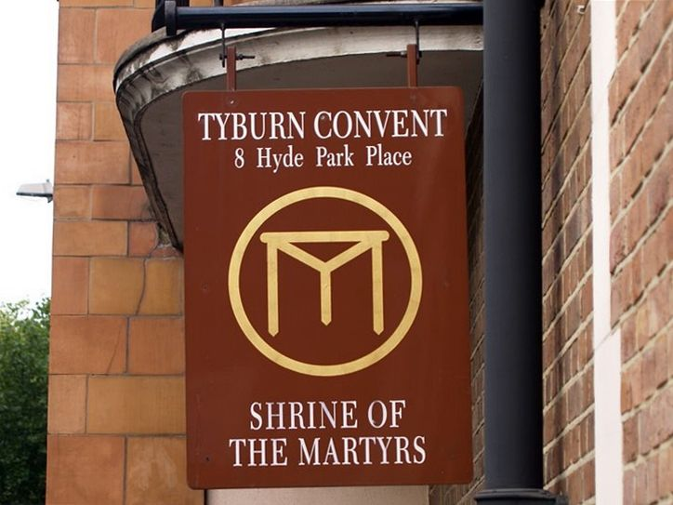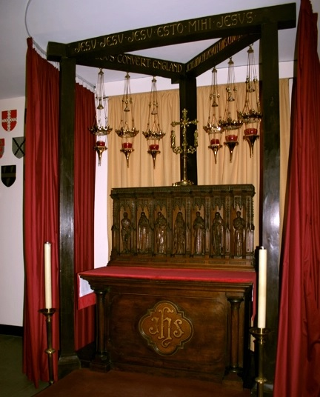
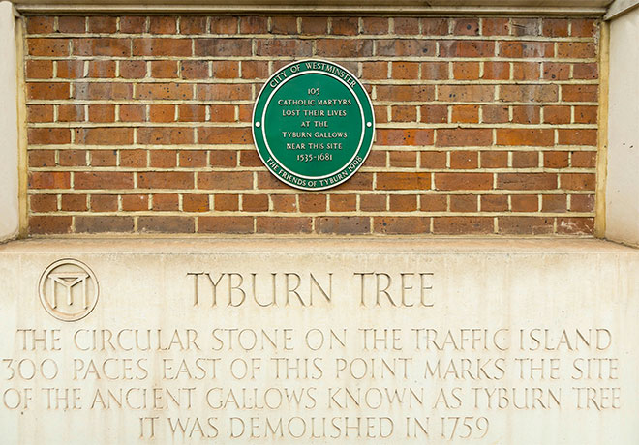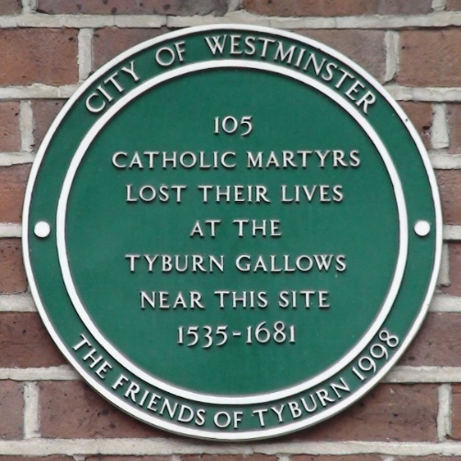
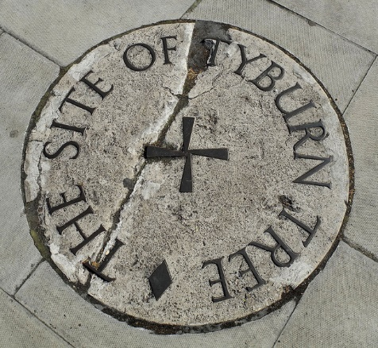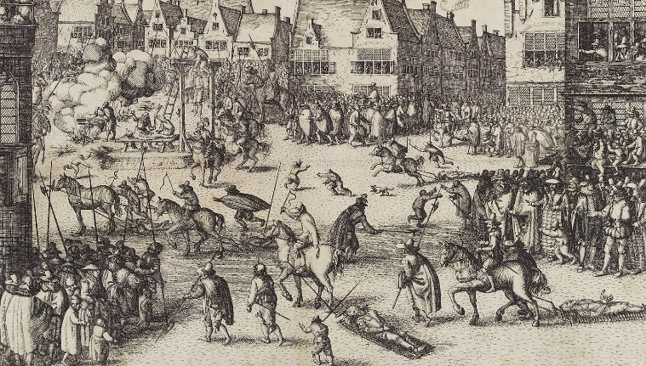

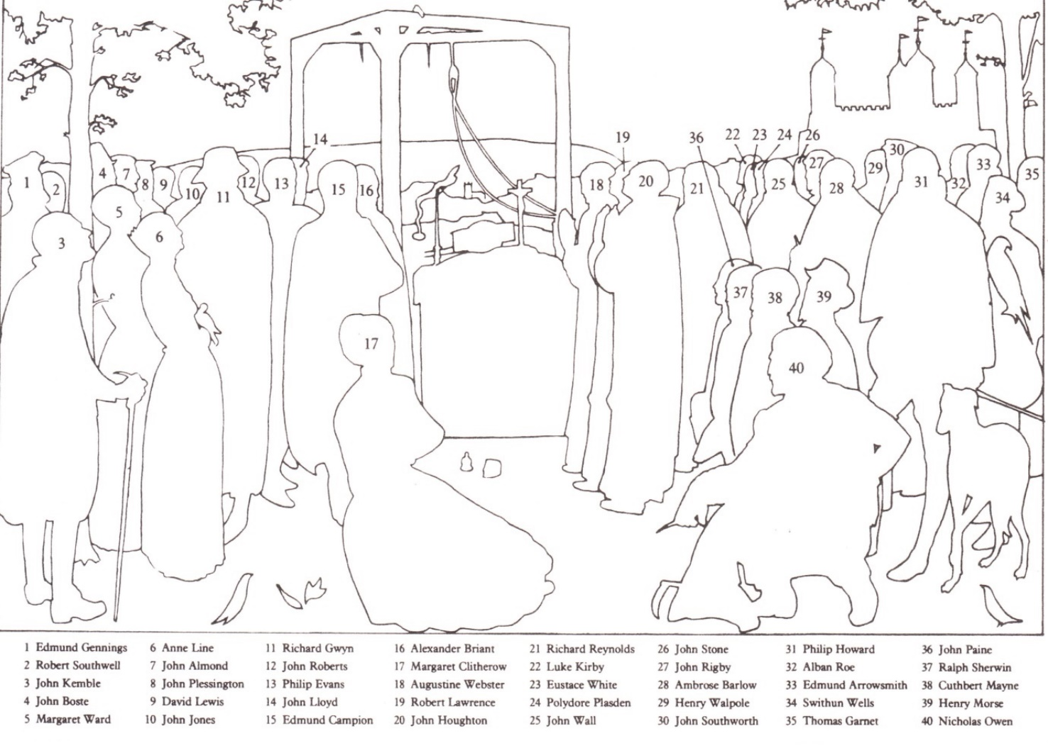

‘The Forty English Martyrs’ Painting

Commissioned by the General Postulation of the Society of Jesus, and painted in 1968 by Daphne Pollen (1904–1986). The picture was taken to Rome for exhibition in 1970, at the time of the canonisation.
The original is now at Stonor Park in Oxfordshire.

Daphne’s son Francis Pollen was the architect who designed Worth Abbey. The bronze tabernacle doors in the Blessed Sacrament Chapel at Worth are the work of his brother, Patrick Pollen; the crucifix over the high altar, and the limestone Madonna and Child are the work of their father, Arthur Pollen, Daphne’s husband.

